School of Computer Science and Artificial Intelligence

LabAssignment#4.2

Program :B.Tech(CSE) Specialization :AIML
Course Title :AI Assisted Coding Course Code : 23CS002PC304
Semester : VI AcademicSession:2025-2026
Name of Student :B . Manali
Enrollment No. : 2303A52187
Batch No. : 34
Date :19/01/26

Task–1:ZERO-SHOTPROMPTING
PromptUsed:
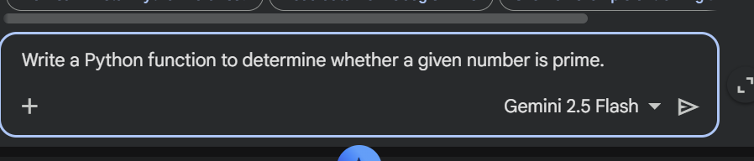
Code:

defis_prime(number): """
Determineswhethera givennumberis prime.

Aprimenumberisanaturalnumbergreaterthan1thathasnopositive divisors other than 1 and itself.

Args:
number(int):Theintegerto check for primality.

Returns:
bool:Trueifthenumberisprime,Falseotherwise. """
ifnotisinstance(number,int):
raiseTypeError("Inputmustbeaninteger.") if number < 2:
returnFalse#Numberslessthan2arenotprime for i in range(2, int(number**0.5) + 1):
ifnumber%i ==0:
returnFalse#Foundadivisor,soit'snot prime

returnTrue#Nodivisorsfound,it's prime

#Example usage:
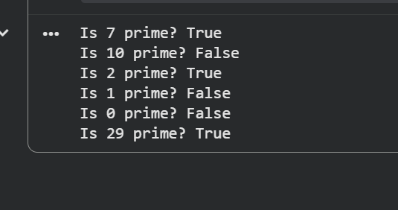
print(f"Is 7 prime? {is_prime(7)}") print(f"Is10prime?{is_prime(10)}") print(f"Is 2 prime? {is_prime(2)}") print(f"Is 1 prime? {is_prime(1)}") print(f"Is 0 prime? {is_prime(0)}") print(f"Is29prime?{is_prime(29)}") Output:

Explanation
The function is_prime() checks whether a given number is prime. It first validates that the inputisanintegerandraisesanerrorifnot.Numberslessthan2areimmediatelyconsidered non-prime.Thefunction thenchecksdivisibilityonlyuptothesquarerootofthenumberfor efficiency. If any divisor is found, it returns False, otherwise it returns True, confirming the number is prime. Example outputs demonstrate correct behavior for different inputs.

Task–2:ONE-SHOTPROMPTING
PromptUsed:
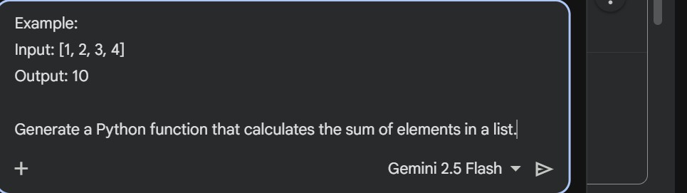
Code:
defcalculate_list_sum(input_list): """
Calculatesthesumof allnumericelementsina list.

Args:
input_list(list):Alistcontainingnumericelements.

Returns:
(intorfloat):Thesumof theelementsinthe list.

Raises:
TypeError:Iftheinputisnotalist. """
ifnotisinstance(input_list, list):
raiseTypeError("Inputmustbealist.")

total_sum =0
foritem in input_list:
#Optional:Addcheckfornon-numericitemsifstrictnessisrequired

#ifnotisinstance(item,(int,float)):
# raiseTypeError(f"Allelementsinthelistmustbenumbers.Found:{type(item)}") total_sum += item
returntotal_sum

#Example usage:
list1=[1, 2, 3, 4]
print(f"Input:{list1},Output:{calculate_list_sum(list1)}")

list2=[10, 20, 30]
print(f"Input:{list2},Output:{calculate_list_sum(list2)}")

list3 =[]
print(f"Input:{list3},Output:{calculate_list_sum(list3)}")

list4=[5.5, 2.5, 1.0]
print(f"Input:{list4},Output:{calculate_list_sum(list4)}")
Output:
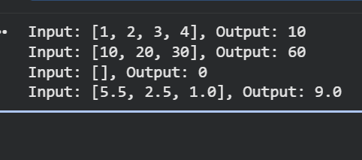
Explanation
Thefunctioncalculate_list_sum()computesthetotalsumofallelementsinagivenlist.Itfirst checkswhethertheinputisavalidlistandraisesanerrorifnot.Thefunctiontheninitializesa variabletotal_sumtozeroanditeratesthrougheachelementinthelist,addingthemtothetotal.

Finally,itreturnsthecalculatedsum.Theexampleoutputsshowthatthefunctionworks correctly for integer, float, and empty lists.
Task–3:FEW-SHOTPROMPTING
PromptUsed:
Examples:
Input:"a1b2c3"→Output:"123" Input:"abc456"→Output:"456" Input: "x9y8" → Output: "98"
Writeafunctiontoextractdigitsfromanalphanumericstring.
Code:

defextract_digits(input_string): """
Extractsalldigitcharactersfromanalphanumericstring.

Args:
input_string(str):Thealphanumericstringtoprocess.

Returns:
str:Anewstringcontainingonlythedigitsfromtheinput_string.
Returnsanemptystringifnodigitsarefound.
"""
ifnotisinstance(input_string,str):
raiseTypeError("Inputmustbeastring.")

digits=""

forcharininput_string: if char.isdigit():
digits+=char return digits

#Exampleusage:
input1="a1b2c3"
print(f"Input:\"{input1}\"->Output:\"{extract_digits(input1)}\"")

input2="abc456"
print(f"Input:\"{input2}\"->Output:\"{extract_digits(input2)}\"")

input3="x9y8"
print(f"Input:\"{input3}\"->Output:\"{extract_digits(input3)}\"")

input4="hello_world"
print(f"Input:\"{input4}\"->Output:\"{extract_digits(input4)}\"")

input5="123testing456"
print(f"Input:\"{input5}\"->Output:\"{extract_digits(input5)}\"")
Output:
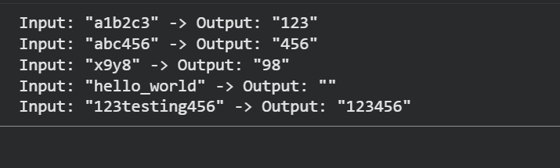

Explanation:
The function extract_digits() extracts onlythenumeric characters from a given alphanumericstring.Itfirstcheckswhethertheinputisavalidstringandraises an error if not. The function then iterates through each character of the string and uses the isdigit() method to identify digits.All detected digits are concatenatedinto anewstring,which is returned as the final result.If no digits are present, the function returns an empty string.

Task–4:ZERO-SHOTVSFEW-SHOTCOMPARISON
- Zero-shot Prompt
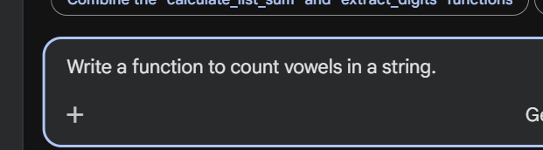
Code:
defcount_vowels(input_string): """
Countsthenumberofvowels(a,e,i,o,u,case-insensitive)inastring.

Args:
input_string(str):Thestringtoanalyze.

Returns:
int:Thetotalcountofvowelsinthestring.

Raises:

TypeError:Iftheinputisnotastring. """
ifnotisinstance(input_string,str):
raiseTypeError("Inputmustbeastring.")

vowels="aeiouAEIOU" vowel_count = 0
forcharininput_string: if char in vowels:
vowel_count+=1 return vowel_count

#Exampleusage:
print(f"'HelloWorld'has{count_vowels('Hello World')}vowels.")
print(f"'PythonProgramming'has{count_vowels('PythonProgramming')} vowels.")
print(f"'AEIOUaeiou'has{count_vowels('AEIOUaeiou')}vowels.") print(f"'Rhythm' has {count_vowels('Rhythm')} vowels.")
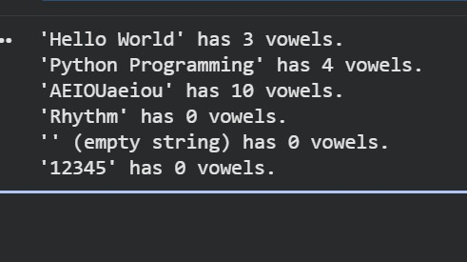
print(f"''(emptystring)has{count_vowels('')}vowels.") print(f"'12345' has {count_vowels('12345')} vowels.") Output:

Explanation:
Thefunctioncount_vowels()calculatesthetotalnumberofvowelsinagiven string. It first checks whether the input is a valid string and raises an error if not. A string containing all uppercase and lowercase vowels is defined, and thefunctioniteratesthrougheachcharacteroftheinput.Ifacharactermatches any vowel, the counter is increased. Finally, the function returns the total vowelcount.Theexampleoutputsconfirmcorrectbehaviorfordifferenttypes of inputs.
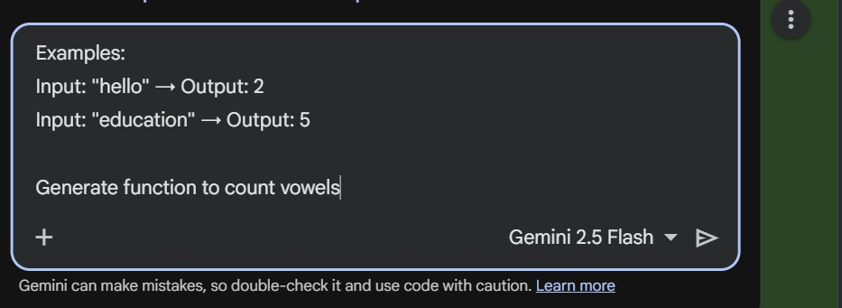
- Few-shotPrompt:
Code:
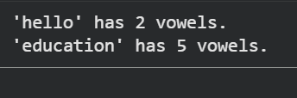
print(f"'hello' has {count_vowels('hello')} vowels.") print(f"'education'has{count_vowels('education')}vowels.") Output:

Explanation:
Thisdemonstratehowthefunctionworkswithsampleinputs.Theword “hello” contains 2 vowels, and “education” contains 5 vowels, which confirms that the function correctly counts vowels in different strings

Task–5:FEW-SHOTPROMPTING
PromptUsed:
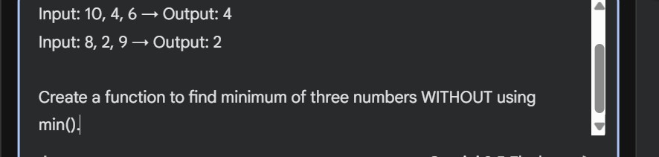
Code:
deffind_minimum_of_three(num1,num2,num3): """
Findstheminimumofthreegivennumberswithoutusingthebuilt-inmin() function.

Args:
num1 (int or float): The first number. num2(intorfloat):Thesecondnumber. num3 (int or float): The third number.

Returns:
(intorfloat):Thesmallestofthethreenumbers. """
ifnotall(isinstance(arg,(int,float))forargin[num1,num2,num3]): raise TypeError("All inputs must be numbers.")

ifnum1<=num2andnum1<=num3: return num1

elifnum2<=num1andnum2<=num3: return num2
else:
returnnum3

#Exampleusage:
print(f"Input:3,7,5→Output:{find_minimum_of_three(3,7,5)}")
print(f"Input:10,4,6→Output:{find_minimum_of_three(10,4,6)}")
print(f"Input:8,2,9→Output:{find_minimum_of_three(8,2,9)}")
print(f"Input:1.5,0.5,2.0→Output:{find_minimum_of_three(1.5,0.5,2.0)}")
print(f"Input:5,5,5→Output:{find_minimum_of_three(5,5,5)}")

Output:
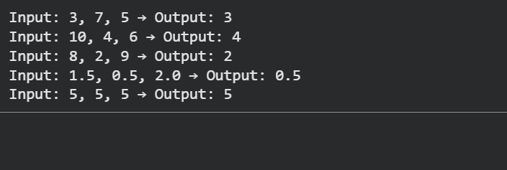
Explanation:
The function find_minimum_of_three() determines the smallest value among threenumberswithoutusingthebuilt-inmin()function.Itfirstverifiesthatall inputs are numeric values and raises an error if invalid data is provided. The function then compares the three numbers using conditional statements. If the first number is less than or equal to the others, it is returned as the minimum. Otherwise, the second or third number is returned based on comparisons. The example outputs confirm that the function correctly identifies the minimum value in different cases.

